SPECIAL SURGICAL HOSPITAL ‘MEDIKUS’

42 Živke Damjanović Street, 35230 Ćuprija

‘ INSTITUE FOR CLINICAL REHABILITOLOGY TULA’
21 Оbornnaja, 300041 Tula,Russian Federation

STUDY

For the new medical technology named
Gradual fibrotomy by Ulzibat

Ćuprija 2016

1

Special surgical hospital ‘ Medikus’ in Ćuprija in cooperation with the experts from
the ‘ Institute for clinical rehabilitology’ in Tula, The Republic of Russia, will introduce
a new method of surgical treatment of muscular conctractures at the patients with pathological
locomotory apparatus. At the beginning we will briefly discuss on the method:

DISCUSSION:

Меdical technology ‘ Gradual fibrotomy in orthopaedics’ represents the method of surgical
elimination of muscular conctractures at the patients with pathological locomotory apparatus.
The technology boasts high efficiency and functionality thanks to the simultaneous affection
different groups of skeletal muscles taking into account their synergy and antagonism ,
which leads to correction of pathological deformity and elimination of painful syndrom in
orthopaedic diseases. The essence of the technology lies in the gradual cutting of painful
syndrom in ortopeadic diseases.
The construction of the scalpel makes the intervention minimally traumatic. The lack of
immobilisation by plaster in post-operational period leads to shorter recovery and higher
efficiency of rehabilitation.
Medical technology is designed for doctors: orthopaedic-traumatology surgeons, surgeons, and
rehabilitologists.

Patent protection: USSSR Patent number 1621901, ‘ Method of treating muscular-facial
pains, Ulzibat V. B., of 1.07.1991., with the priority of 24.09.1987., Russian Federation
Patent number 2124864, ‘ Method of treating orthpaedic concequences of infantile
cerebral paralysis’ of 20.01.1999., with the priority of 7.07.1998., USSSR Patent number
1560143, ‘ micro-fibrilotom by Ulzibat V.B. of 1.07.1991., with the priority of 17.08.1987.

The author of the method: professor, doctor of medical science, honoured inventor of
Russian Federation Ulzibat V.B.

Prepared and fulfilled by the organization: Special surgical hospital ‘ Medikus’ from
Ćuprija with the Closed Joint Stock Company ‘ Institute for Clinical Rehabilitology’
Tula, Russia.

2

INRODUCTION

For successful treatment of patient with orthopaedic profile, it is necessary to reveal and
eliminate organic muscular contractures at the eary stage and this prevent the invalidisa-
tion of the patient.
In cases of innate and acquired orthopaedic pathology, the dystrophic and sclerotic
modifications in skeletal muscles are developed in different rates.
It was established that development of dystrophic and sclerotic modifications in skeletal
muscles is one of the reasons of muscle disfunction, myofacial pain and locomoroty distu-
rbnace being different by nosology.
Early revelation and elimination of muscular conctractures represents a necessary condition
in treating orthopaedic profile, since a long-term painful syndrom can lead to development
of conctractures and deformity of locomotor apparatus.

The method of gradual fibrotomy consists in elimination of organic muscular
contractures and myofacial pain syndrom based on the gradual under-tissue cross-cutting
of fibrotic modified muscle fibres in the area of their attachment to the bone. .
(USSSR Patent number 1621901 of 24.09.1987.) by means of specially designed scalpel
(micro-fibrilotom of Ulzibat V.B. , USSR Patent number 1560143 of 17.08.1987., and
Russian Federation Patent number 2124864 , ; Method of treating the consequences
of infantile cerebral paralysis’ of 20.01.1999. (priority of 7.07.1998.) and belongs to the
field of orthopaedics.
The suggested method differs from the exisiting ones in maximal functionality, thanks to
simultaneous affection on different groups of skeletal muscles taking into account their
synergy and antagonism, which leads to correction of pathological deformity
and elemination of painful syndrom in orthopaedic diseases.
The operative treatment course, consisting of 12-16 gradual fibriotomia
lasts for 15-20 minutes, which enables the surgery being done in ambulance
conditions , on the basis of daily surgical hospital. The lack of immobilisation by
plaster in postsurgical period leads to shorter recovery period and higher efficiency
of rehabilitation.

INDICATION FOR APPLICATION OF THE MEDICAL TECHNOLOGY

Indications for application medical technology are:
-availabilty of organic muscular concractures and chronic myofacial pain syndrom
that cause difficult muscle function deformity (МКБ - 10; Class 13, М 62. 4
Muscle conctractures; М 79. 1 Мialgy);
-absence of effect of convenctional therapy

CONTRAINDICATION FOR APPLICATION OF THE MEDICAL TECHNOLOGY

Absolute contraindications for application of the medical technology are:

-availability of congenital abnormalities and chronic illnesses at the decompesation stage;
-psychological illnesses at the deteorating stage
-pregnancy;
-difficult organ illnesses in deteorating stage;
-disturbance of function of vitally imoprtant organs.

Relative contraindications for application of medical technology are:
-acute infective and somatic ilnesses (including period of reconvalescence);
-acute and subacute neuroinfection, head injury and brain blood flow disturbance;
-chronic illnesses in the period of recrudescence;
-intolerance of medicinal preparation for anaesthesia
-availability of difficult allergies in the case history;
-availability of damages and inflamatory diseases of skin and soft tissues;
-condition after epiliptic seizures: after "small" – ate least 3 months, after ‘big’
(generalized) – at least 6 months, after epileptic sthatus – at least 12 months;
-codition after injected botox (dysport) – at least 6 months;
-post vaccination state – at least 1 month.

MATERIAL- TECHNICAL STRUCTURES IN THE SPECIAL SURGICAL
HOSPITAL –MEDIKUS-

1.Policlinical part of the hospital consists of: waiting room for the patients, reception desk,
examination office, wounds treatment ward, sanitary washroom and sewer system.

2.Operating theatre consists of: the outer green zone room- reception part,
changing room for patiens, changing room for personnel; inner green zone room –
premedication, preoperational room, room for surgical hand washing,
sterilization room and the operation room which meet the standards of ‘ Regulations
about the conditions of health practice in health facilities and other forms of
health service ''( State Register SR, no.43/2006, 112/2009 ).
3.Equipment and monitoring for anaesthesia,instrument room, sterilization equipment, surgical
light, operating table, electric scalpel, aspirator, laparoscopic equipment etc.
4.Instrument: microfibrilotom Ulzabat V.B. (USSSR Patent number 1560143, priority of
17.08.1987.), approved for the medical usage by the Committee for new medical

techology in the Russian Ministry of Health
(session protocol of the Committee for the appliances, devices and instruments used in
traumatology , orthopaedics and mechanotherapy number 4 from 24.06.1998.
state register of medical instruments no FSR 2008/02296 of 18.03.2008.)

DESCRIPTION OF MEDICAL TECHNOLOGY

Before surgery, the surgeon analyses the case history and the condition the patient is into
by examining the main coctractures and deformities of locomotor apparatus and determines
localization of myofacial painful syndrom
The standard methods of examination are used in determining the patient’s status:
observation, palpation, angulometry, X-ray, plantography and electromyography
(Images no 1 and 2)

Image no 1: X-ray of ankle, angle= 140 degrees

Image no 2: Plantograph before surgical intervention
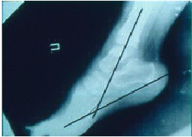

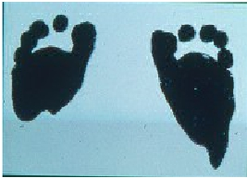

The intensity of myofacial pain syndrom is determined by the means of psychological-
algometric scale. By deep palpation of standard muscle points which are used in the
process of motion we determine the idurated sections of the muscle which are algetic
during palpation and do not disappear after muscle relaxation. It is necessary to point
that a number of muscle conctractures eg. in oblique stomach muscles,
musculus gluteus, coctractures can not be determined by visual examination but only by
palpation.
To establish the form and the intensity degree of conctractures, deformation and diferentiation
of functional and organic level of muscle contctractures, inhalation narcosis is applied, surgical
level (2-3 level).
In the state of complete relaxation functional conctractures disappear, while оrganic
muscular conctractures remain in the form of indurated fibrotic fold.

Image 3. Clinical examination in the condition of relaxation.

Under total anesthesia or after local anesthetic infiltrated, with the previous
appilcation of standard antiseptics , in the projection of muscle conctracture
a punction of skin in the length of the scalpel is done with the sterile scalpel (microfibrilotom)
all the way to the zone of dead muscular fibres.
Then with the working part of the scalpel , its wider side, we search for the coctractures,
and by turning the instrument with sharp edges towards it we do the cutting of fibre fold.
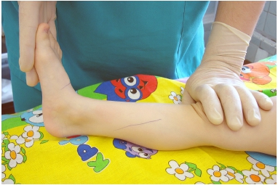

Image 4. Intervention scheme

Image 5. Skin punction
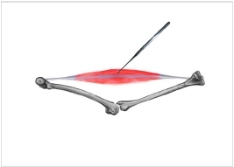

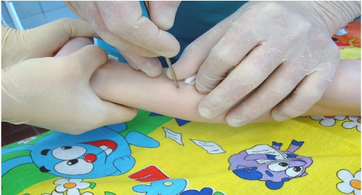

Image 6. Cutting dead muscle fibres

The action is always followed by characteristc ‘crunching", which, when it stops, confirms
the end of procedure. The construction of the scaplel makes the procedure least traumatic.
After cutting the fibre fold in one muscle section the procedure is repeated in other
sections in which other muscle conctractures had been noticed before.
Spotted wound are then covered with sterile bandage. Aseptic bandages can be removed
after 24 hours.
For successful treatment of patients with orthopaedic syndrom, it is necessary to reveal
and eliminate organic muscular contractures at an eary stage, since their development
may lead to a greater and more traumatic surgical intervention.
However, if the flexion conctracture which is usually in the knee, is bigger than 40°,
redresation should not be bigger than 20° per phase of operation.
Underestimation of this fact may lead to the traction damage of fibular nerve.

Image 7. Achieved result scheme
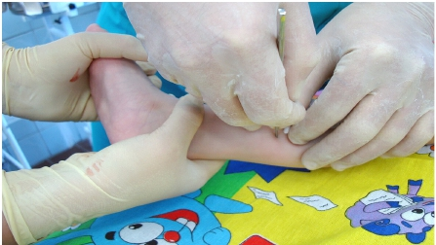

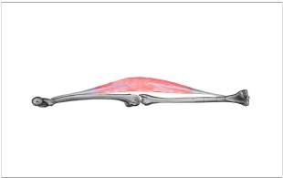

Image 8. Post-operative clinical examination

Image 9. Post-operative clinical examination

Image 10. Post-operative X-ray
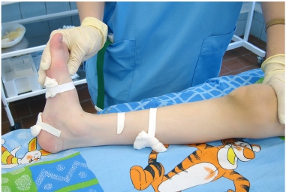

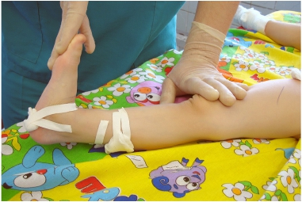

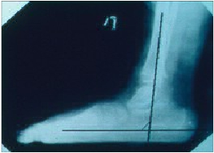

Image 10. Post-operative plantograph

POSSIBLE COMPLICATIONS AND THE MEANS OF ELIMINATING

As with all surgical interventions the complications may occur:

EFFICIENCY OF THE MEDICAL TREATMENT

Data analysis of the efficiency of gradual fibrotomy application is dane on the personal
computer using the standard methods of stathistics . What was assessed was the research
done by the orthopaedist and neurologist taken in each phase of patient treatment,
data on the analysis of the patients’ condition were collected by the independent physicians-
experts and the data from the medical documentation (ambulance charts, discharge papers)
and survey of catamnesis filled by patients or their parents.
The institute for clinical reahabilitology deals with the patients with different congenital
or acquired orthopaedic diseases:

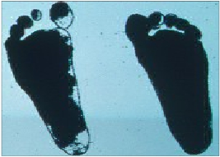

Complications | Means of eliminating
Damage of the blood vessel | Tying off the vessel
Breaking of the tip of the scalpel | Extracting
Infection of post-operative hematoma | Treatment with the standard medicine
Peripheral nerve injury  А) complete injury  Б) partial injury  В) тraction injury | Surgical recovery of the nerve by treatment  and healing.  Medicamentous treatment
Tеndion injury  Occurence of pain in other muscles | Tendion stitching  Elimination in the next treatment phase

congenital muscular torticollis, congenital scoliosis and foot deformities, orthopaedic
consequences of infantile palsy, effects of traumatic and inflamatory damage of loco-
motor apparatus, траumatic brachial plexus injury at giving birth, scoliosis, muscular-
tonic syndrom at osteohondrosis, scapulo-umeral peri-arthritis, epicondilitis, sti-
loiditis, Dupuytren’s conctracture, myofacial pain syndrom. For 25 years of Institute operation
more than 45000 patients were taken for treatment (data on 17.01.2018.), including
37000 children. Annualy we operate on about 3500 patients, among which 1500
primary patients, with more then1200 children. On average, every patient had
two phases in the treatment ( 2 operations), and within the scope of one phases there
were 12-16 gradual fibrotomies.
Table 1. The analysis of the sample group patients treatment results in the period 1993- 2016

Post- operatively, for 15 days any types of activities are not recommended, and
after that period physical therapy with the accent on hydro-therapy and water massage is
necessary .

Analysis of long-term treatment of 3849 patients that was carried out by physicians
from various cities in Russia and by the Institute collaborators during the period of 1993-
2016 has shown the ‘good’ clinical effect in 92.87 %. By eliminating muslce
conctractures the following results were achieved: improvement of intromuscular
hemodinamics,normalization of muscle tone, increased volume of motion and the intensity
of spasms and relaxation and decreased volume of joint contractures served by the given
muscles.At these patients a complex of new motor functions has developed,
a qualitatively new motor stereotype was formed as well as the elimination or
reduction of pain syndrom and hyperkineses.With 4.34 % of patients a ‘satisfactory’
result was noted – improvement of some motor skills expanison of functional within
the initial level of motor development..
In 2.79% cases, patients’s state remained ‘without dinamics’. With 0.03% patients,
appearance of pain in muscle areas that were not operated earlier was considered as
‘aggravation’, these modifications were eliminated at the subsequent stages of treatment.
With regard to local organic muscular contractures or point of reference, efficiency
of gradual fibrotomy amounted in average to 97.5 %.
In more than 50% cases the changes of motor functions have shown qualitative
character. In addition to improvement of loco-motor development with
The result | no. of patients 3849 | Percent (%)
Good | 3573 | 92.84%
Satisfactory | 167 | 4.34%
No changes | 108 | 2.80%
the elimination of muscular contractures, additional positive effects were noted:

Table 2: Additional positive effects

The frequency of qualitative changes (occurence of speech and chewing, dissapearance
of salivation) was 35%.

Follow-up monitoring (catamnesis) of patient’s condition confirms that for reaching the maximal
positive clinical result with minimal number of surgeries and treatment phases
it is necessary to apply the method of gradual fibrotomy at an early stage of muscle conctractures
forming, before the appearence of ankle conctractures and the deformity of
locomotor apparatus.
Additional positive effects | no of patients 3849 | percent %
Speech improvement | 2386 | 62,00%
Mastication | 1886 | 49,00%
Deglutition | 1924 | 50,00%
Mimics | 847 | 22,00%
Emotional behaviour | 2463 | 64,00%
Sleep | 1886 | 49,00%
Orexia | 2232 | 58,00%
Decrease
Strabismus | 2117 | 55,00%
Salivation | 2155 | 56,00%
Nystagmus | 847 | 22,00%
Frequency and severity of epi seizures | 962 | 25,00%
Improvement
sight | 654 | 17,00%
hearing | 577 | 15,00%

Table view of this method compared to the classical

This table also shows economic and social benefits compared to
classical opeartion at the patients where both methods can be applied.

1.THE LIST OF WORKS PUBLISHED IN MAGAZINES
AND PRESENTED AT THE CONGRESSES

1.USSSR Patent no. 1560143 "Microfibrilotom by Ulzibat" оf 1.07.1991. with
the priority of 17.08.1987.
2.USSSR Patent no. 1621901 " The method of treating muscular-facial pains Ulzibat.
V.B." оf 1.07.1991. with the priority of 24.09.1987.
3.Russian Federation Patent no. 2124864 "The method of treating the consequences
of infantile cerebral paralysis" одf20.01.1999. with the priority of 7.07.1998.
4.Methodical recommendation "Muscular-facial pains, diagnostics and pathological-
treatment" issued by the Ministry of health of the USSSR, no. 10-11/35 оf 20.02.1990.
5.Ulzibat V.B. Muscular-facial pains: pathogenesis, клиничка слика and
trеatment. //Rheumatology. 1990. no. 4, p. 71.
6.The mechanism of forming pain syndrom in cases of miofibrilosis (мuscular-
faciаl pains). Ulzibat V.B., Shishov S.V., Nazarov I.V., Јersov V.L., Кiseljov
А.V: Paper theses from the 1st conference of the Russian Association for pain study. 19-21.
October 1993. . М. 1993. p. 46.
7.Ulzibat V.B., Shishov S.V.. Surgical treatment of primary fibromyalgia
(мiofibriosis) / Operative treatment of primary fibromyalgia (myofibrillosis)//Comple-
mentary Therapies in Medicine. 1995. No. 3, p. 72 -74.
8.New methods of surgical rehabilitation in cases of infantile invalidilty.
Ulzibat V.B., Shishov S.V., Nazarov I.V, Sozontov А.А, Jersov V.L., Тregubov
А.I.//Pediatrics.1995. No. 4, p. 117-118.
9. Ulzibat V.B., Shishov C.V., Nazarov I.V. New methods of surgical rehabilitation
in cases of infantile invalidity. Paper theses // International magazine for
immunorehabilitology. Јune 1995. Soci, Dagomis. 1995. No. 261.
 | fibriotomy by Ulzibat | Classical operation
Number of conctractures | 12 - 16 | 1-2
Number of days spent in hospital | 1 | 7 - 10
Post-operative plaster | no | yes 4 – 6 weeks
Invasion of the method | мinimal | big
Home care | Only in first 2 days after intervention | 4 – 6 weeks
Possible muscle athrophy | no | big

10.Ulzibat V.B. Organization of surgical treatment in ambulance condition of the patients
with pathology of locomotory apparatus: М. 1996, 174 стр.
11.Ulzibat V.B. Tsoi J.V.. The syn-
drome of muscle fascial pain in pediatry: Abstracts Fourth International Symposium on
pediatric pain. 29 June - 2. July 1997. Helssinki, Finland. 1997, p. 183 – in englis
12.Ulzibat V.B. Orthopaedic help in ambulance conditions in non-state
medical facility. Тula. 1998, 194 pp.
13.Ulzibat V.B., Sisov S.V., Tsoi J.V., Budarin V.I., Repetunov A.A., Algorythm
of diagnostics of the syndrom of muscular-facial pains at children: Зборник
"Defending the questions of ortopaedics in ambulance conditions". Тula. 2001.
2, pp 54-59
14. Ulzibat V.B., Sisov S.V., Tsoi J.V., Budarin V.I., Repetunov A.A. Оrthopaedic
problems of the patients with heavy head trauma: Мат. I Allrussian
Congress "Modern technology in paediatrics and infantile surgery", 16-19. October
2002. p. 382.
15.Tsoi J.V. Clinical-diagnositc characteristics syndrom of muscular-facial pain
syndrom at children./. М. 2003. 180 стр.
16.Tsoi J.V., Budarin V.I., Repetunov А.А, Sulga Ј.V. Characteristics of rehabilitation
of the children with pathological locomotor apparatus and infantile cerebral paralysis
using the methods of gradual fibriotomy by Ulzibat V.B.: Мат. VI Russian
Congress "Modern technologies in paediatrics and infantile surgery". 23-25. November
2007. Moscow. 2007, pp. 311-312.
17.Coj.J.V. Prevention of myofacial pain syndrom at children: Мат. VII Russian
congress " Modern technologies in paediatrics and infantile surgery ". 21-23. October
2008. Moscow. 2008, p. 428.
18.Alexandar J.N. The influence of gradual fibrotomy on the range of movement and
motor function. Мат.5. World congress of international association of physical and
rehabilitational medicine. 13–17 June 2009. Istanbul, Turkey. П-1676.

